MMAN2300

Lab Report: Rotating Mass Unbalance

Dan Nguyen, z5206032

Wednesday, 3 July 2019, 14:00

**Abstract**

This report explores the vibration analysis of a rotating mass unbalance which can be examined by considering the free and forced responses of the system. Analysing the beam in free response yielded undamped natural frequencies. These results are discussed with consideration of discrepancies, comparisons made between free response results for one vs five cycles, and experimental vs theoretical results. Analysing the forced response of the system yielded the experimental amplitude of oscillation vs frequency ratio of the rotating disc. This was compared analytically to a theoretical graph.

Table of Contents

1. Introduction 3

2. Rotating Mass Unbalance Experiment 3

2.1. Experimental Setup 3

2.2. Free Response Experimental Method 4

2.3. Forced Response Experimental Method 4

2.4. Experimental Results 5

3. Calculations for Free Response of System 6

3.1. Calculation of Theoretical Natural Frequency 6

3.2. Free Response for 1 Cycle 8

3.3. Free Response for 5 Cycles 9

4. Calculations for Forced Response of System 10

4.1. Experimental Forced Response Graph 10

4.2. Theoretical Forced Response Graph 12

5. Discussion 13

5.1. Comparison of Free Response of One Cycle and Five Cycles 13

5.2. Comparison of Experimental and Theoretical Free Response 14

5.3. Comparison of Forced Response Graphs 14

6. Conclusion 15

7. References 16

8. Appendix 17

# Introduction

A rotating mass unbalance has an uneven distribution of mass about its centre of rotation which creates a system for vibration analysis. This system was replicated with a disc (of uneven distribution of mass) attached to a motor centred on a beam. The system in free response is oscillating at its natural frequency without a continuously applied external force. Realistically, the system oscillates at the damped natural frequency ($ω_{d}$) which has the amplitude of oscillation decay over time due to resistive forces. The undamped natural frequency ($ω_{n}$) does not have a decay in amplitude. The experimental $ω_{n}$ will be investigated by considering the logarithmic decrement for one cycle and five cycles then compared to the theoretical $ω_{n}$. The system in forced response is oscillating at the excitation frequency ($ω$) of a continuously applied external force ($F_{0}$). The amplitude of oscillation ($X$) does not decay and is dependent on the frequency ratio ($r$) which is the ratio of the excitation frequency to natural frequency. $X$ is maximum during resonance as the excitation frequency oscillates at the natural frequency of the system causing a peak in an $X$ vs $r$ graph at $r=1$.

# Rotating Mass Unbalance Experiment

The aim of the experiment is to analyse the free and forced response of the beam. The undamped natural frequency was obtained experimentally and theoretically from the free response of the beam. The amplitude vs frequency ratio was obtained experimentally from the forced response of the beam.

## Experimental Setup

The experiment was setup as in *figure 1* below. A power supply and DC motor with an attached disc with uneven mass distribution generates the sinusoidal excitation force from the centre of a slightly damped beam. An accelerometer placed on the beam is connected to a charge conditioning amplifier which is connected to an oscilloscope. The accelerometer measures the acceleration of the oscillating beam.

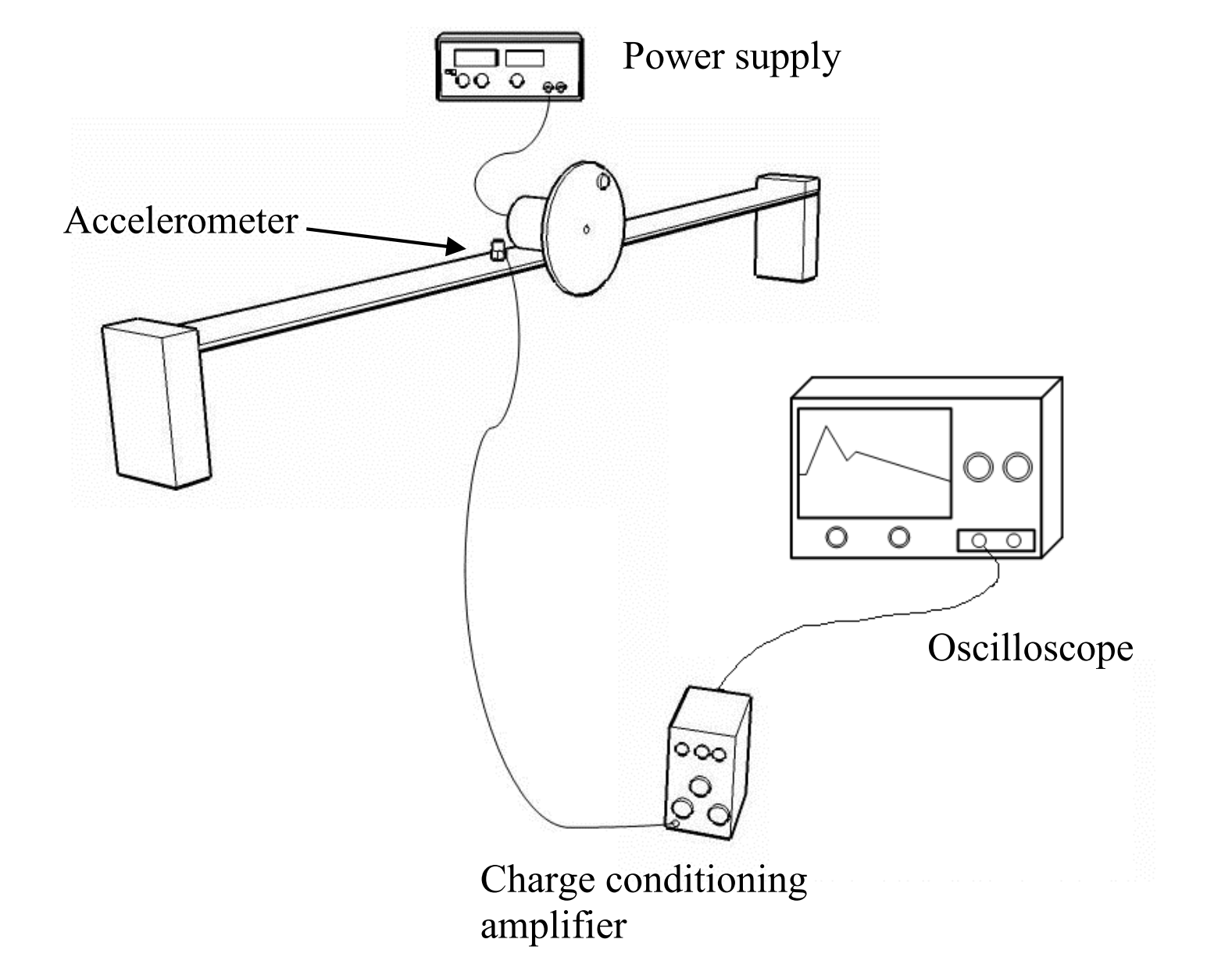

*Figure 1. Experimental Setup of Rotating Mass Test Rig and Instruments (Lab Hand-Out)*

Equipment:

* Power Supply
* DC Motor
* Accelerometer
* Charge Conditioning Amplifier
* Oscilloscope
* Aluminium Beam (40mm x 3mm x 570mm)

## Free Response Experimental Method

The first part of the experimental method is the analysis of the beam in free response.

1. Using only the oscilloscope. Calibrate the oscilloscope’s horizontal and vertical zoom by striking the beam with a soft object or finger. Set the trigger level to an appropriate value to get a stabilised frame of the free response of the system.
2. Strike the beam with a soft object or finger.
3. Use the cursor of the oscilloscope to obtain the values of two consecutive peaks of the free response wave ( $X_{1}$ and $X_{2}$) and the period ($T_{d}$) of the wave.
4. Record $X_{1}$, $X_{2}$ and $T_{d}$.
5. Repeat steps 2-4 for 6 trials.
6. Calculate the theoretical undamped natural frequency from given information (lab handout).
7. Calculate the experimental undamped natural frequency by calculating the logarithmic decrement ($δ$), damping ratio ($ζ$), damped natural frequency ($ω_{d}$), and undamped natural frequency ($ω_{n}$). See Chapter 3 for explicit detail of calculations.

## Forced Response Experimental Method

The second part of the experimental method is the analysis of the beam in forced response.

1. Turn on the peak-to-peak amplitude and frequency reading on the oscilloscope. Turn off the trigger level.
2. Put the output voltage of the power supply to zero; turn on the power supply and charge conditioning amplifier. This ensures a controlled environment to begin the experiment.
3. Increase the voltage by a small value. Avoid the natural frequency of the beam as a forced response at the natural frequency will cause resonance and damage the setup.
4. Pause the oscilloscope to record the peak-to-peak amplitude and frequency then resume.
5. Repeat steps 3-4 for many trials before and after the resonance frequency.
6. Calculate the amplitude of oscillation and frequency ratio from experimental results.
7. Plot the experimental amplitude vs frequency ratio with curve of best fit.
8. Plot the theoretical amplitude vs frequency ratio with curve of best fit from given information (lab handout).

## Experimental Results

The free response peaks and period of the system for one cycle was recorded in *table 1*.

*Table 1. Experimental Observation of Free Response for 1 Cycle*

|  |  |  |  |
| --- | --- | --- | --- |
| **Trials** | $$X_{1} (mV)$$ | $$X_{2} (mV)$$ | $$T_{d} (ms)$$ |
| 1 | 136 | 126 | 48.0 |
| 2 | 121 | 114 | 48.0 |
| 3 | 116 | 109 | 48.0 |
| 4 | 97 | 90.3 | 48.4 |
| 5 | 107 | 99.5 | 48.4 |
| 6 | 61.1 | 57 | 48.5 |

The free response peaks and period for five cycles was recorded in *table 2*.

*Table 2. Experimental Observation of Free Response for 5 Cycles*

|  |  |  |  |  |
| --- | --- | --- | --- | --- |
| **Trials** | $$X_{1} (mV)$$ | $$X_{5} (mV)$$ | $${4T}_{d} (ms)$$ | $$T_{d} (ms)$$ |
| 1 | 226 | 177 | 192 | 48.0 |
| 2 | 271 | 224 | 192 | 48.0 |
| 3 | 63.6 | 52.0 | 194 | 48.5 |
| 4 | 62.8 | 51.1 | 193 | 48.5 |
| 5 | 70.3 | 58.6 | 193 | 48.25 |
| 6 | 59.5 | 47.0 | 193 | 48.25 |

The forced response results were obtained directly from the oscilloscope and recorded into *table 3*.

*Table 3. Experimental Observation of Forced Response*

|  |  |  |
| --- | --- | --- |
| **Trials** | **Frequency $(Hz)$** | **Amplitude pk-pk $(mV)$** |
| 1 | 14.00 | 52 |
| 2 | 15.28 | 74 |
| 3 | 16.57 | 96 |
| 4 | 17.46 | 132 |
| 5 | 17.93 | 158 |
| 6 | 18.33 | 186 |
| 7 | 18.57 | 214 |
| 8 | 19.69 | 438 |
| 9 | 26.62 | 138 |
| 10 | 33.30 | 94 |
| 11 | 40.05 | 80 |
| 12 | 42.96 | 74 |
| 13 | 47.04 | 70 |

# Calculations for Free Response of System

The intention of calculations for the free response of the system was to obtain $ω_{n}$ using both experimental and theoretical methods. All calculations and graphing were performed using MATLAB (see code in Appendix A to E).

## Calculation of Theoretical Natural Frequency

The theoretical natural frequency is calculated using given information and formulae about the system (refer to Appendix B for calculation).

Given Information:

The following information about the system was given from the laboratory handout:

* Dimensions of the Beam
$b=40 mm$

$h=3 mm$

$l=570 mm$

$ρ_{Aluminium}=2750 kgm^{-3}$

* Young’s Modulus: $E=7.1×{10}^{10} kgm^{-1}s^{-2}$
* Combined Mass of Motor, Disc, Unbalanced Mass: $M=248 g$

Calculating Second Moment of Inertia of Beam Cross-Section:

$$I=\frac{bh^{3}}{12}$$

$$=\frac{(40×{10}^{-3}){(3×{10}^{-3})}^{3}}{12}$$

$$∴I=9×{10}^{-11} m^{4}$$

Calculating Spring Constant:

$$k_{eq}=\frac{192EI}{l^{3}}$$

$$=\frac{192×7.1×{10}^{10}×9×{10}^{-11}}{{(570×{10}^{-3})}^{3}}$$

$$∴k_{eq}=6.6249×{10}^{3} Nm^{-1}$$

Calculating Equivalent Mass:

$$m_{beam}=ρ(b×h×l)$$

$$=2750(40×{10}^{-3}×3×{10}^{-3}×570×{10}^{-3})$$

$$∴m_{beam}=0.1881 kg$$

$$m_{eq}=M+\frac{13}{35}m_{beam}$$

$$=248×{10}^{-3}+\frac{13}{35}0.1881$$

$$∴m_{eq}=0.3179 kg$$

Calculating Undamped Natural Frequency:

$$ω_{n}=\sqrt{\frac{k_{eq}}{m_{eq}}}$$

$$=\sqrt{\frac{6.6249×{10}^{3}}{0.3179}}$$

$$\begin{aligned} ∴ω_{n}=144.3667 rads^{-1}\end{aligned}$$

## Free Response for 1 Cycle

An example of the calculation for the experimental undamped natural frequency was made with trial 1 from *table 1* (refer to Appendix C for calculation).

Calculating Logarithmic Decrement:

$$\begin{aligned}δ=\frac{1}{n}ln\left(\frac{X_{n}}{X_{n+1}}\right)\#\left(1\right)\end{aligned}$$

$$=\frac{1}{1}ln\left(\frac{X_{1}}{X_{2}}\right)$$

$$=\frac{1}{1}ln\left(\frac{136}{126}\right)$$

$$\begin{aligned}∴δ=0.0764\end{aligned}$$

Calculating Damping Ratio:

$$\begin{aligned}ζ=\frac{δ}{\sqrt{4π^{2}+δ^{2}}}\end{aligned}$$

$$=\frac{0.0764}{\sqrt{4π^{2}+{0.0764}^{2}}}$$

$$∴ζ=0.0122$$

Calculating Damped Natural Frequency:

$$\begin{aligned}ω_{d}=\frac{2π}{T_{d}}\end{aligned}$$

$$=\frac{2π}{48.0×{10}^{-3}}$$

$$∴ω_{d}=130.8997 rads^{-1}$$

Calculating Undamped Natural Frequency:

$$\begin{aligned} ω_{n}=\frac{ω_{d}}{\sqrt{1-ζ^{2}}}\end{aligned}$$

$$=\frac{130.8997}{\sqrt{1-{0.0122}^{2}}}$$

$$\begin{aligned} ∴ω_{n}=130.9094 rads^{-1}\end{aligned}$$

*Table 4. Experimental Calculation of Free Response for 1 Cycle*

|  |  |  |  |  |
| --- | --- | --- | --- | --- |
| $$Trials$$ | $$δ$$ | $$ζ$$ | $$ω_{d} (\frac{rad}{s})$$ | $$ω_{n} (\frac{rad}{s})$$ |
| 1 | 0.0764 | 0.0122 | 130.8997 | 130.9094 |
| 2 | 0.0596 | 0.0095 | 130.8997 | 130.9056 |
| 3 | 0.0622 | 0.0099 | 130.8997 | 130.9061 |
| 4 | 0.0716 | 0.0114 | 129.8179 | 129.8263 |
| 5 | 0.0727 | 0.0116 | 129.8179 | 129.8266 |
| 6 | 0.0695 | 0.0111 | 129.5502 | 129.5581 |
| Average | - | - | - | 130.3220 |

The calculated results for the other trials are tabulated in *table 4* (above).

## Free Response for 5 Cycles

The experimental calculation for the free response system for 5 cycles is the same as the previous example calculation. However, the logarithmic decrement for 5 cycles was calculated from equation 1 for $n=5$. The calculated results for 5 cycles are tabulated in *table 5*.

*Table 5. Experimental Calculation of Free Response for 5 Cycles*

|  |  |  |  |  |
| --- | --- | --- | --- | --- |
| $$Trials$$ | $$δ$$ | $$ζ$$ | $$ω_{d} (\frac{rad}{s})$$ | $$ω_{n} (\frac{rad}{s})$$ |
| 1 | 0.0489 | 0.0078 | 130.8997 | 130.9037 |
| 2 | 0.0381 | 0.0061 | 130.8997 | 130.9021 |
| 3 | 0.0404 | 0.0064 | 129.5502 | 129.5529 |
| 4 | 0.0412 | 0.0066 | 130.2215 | 130.2243 |
| 5 | 0.0364 | 0.0058 | 130.2215 | 130.2236 |
| 6 | 0.0472 | 0.0075 | 130.2215 | 130.2251 |
| Average | - | - | - | 130.3386 |

# Calculations for Forced Response of System

The calculations below for the forced response of the system obtains the relationship between $X$ and $r$.

## Experimental Forced Response Graph

The experimental forced response graph was plotted using calculated values of frequency ratio and amplitude of oscillation – the example calculation below uses trial 1 data from *table 3*. The plotting was performed in MATLAB with the curve of best fit (refer to Appendix D for MATLAB code).

Calculating Amplitude of Oscillation:

The forced response peaks were measured in peak to peak values therefore half the peak to peak value will give the amplitude of oscillation.

$$X=\frac{52}{2}=26 mV$$

Calculating Excitation Frequency:

$$ω=2πf$$

$$=2π×14$$

$$\begin{aligned} ∴ω=87.9646 rads^{-1}\#\left(2\right)\end{aligned}$$

Calculating Frequency Ratio:

$$\begin{aligned}r=\frac{ω}{ω_{n}}\#\left(3\right)\end{aligned}$$

Substituting the average $ω_{n}$ from one cycle and ($2$) into ($3$):

$$r=\frac{87.9646}{130.3220}=0.6750$$

The calculated results are tabulated in *table 6* (below).

*Table 6. Experimental Calculation of Forced Response*

|  |  |  |  |
| --- | --- | --- | --- |
| **Trials** | $$X (mV)$$ | $$ω (rads^{-1})$$ | $$r$$ |
| 1 | 26 | 87.9646 | 0.6750 |
| 2 | 37 | 96.0071 | 0.7367 |
| 3 | 48 | 104.1124 | 0.7989 |
| 4 | 66 | 109.7044 | 0.8418 |
| 5 | 79 | 112.6575 | 0.8645 |
| 6 | 93 | 115.1708 | 0.8837 |
| 7 | 107 | 116.6788 | 0.8953 |
| 8 | 219 | 123.7159 | 0.9493 |
| 9 | 69 | 167.2584 | 1.2834 |
| 10 | 47 | 209.2301 | 1.6055 |
| 11 | 40 | 245.3584 | 1.8827 |
| 12 | 37 | 269.9256 | 2.0712 |
| 13 | 35 | 295.5610 | 2.2679 |

Graphing Experimental Forced Response Graph:

The general equation for the amplitude vs frequency ratio of a rotating mass unbalance system is as follows:

$$\begin{aligned}\frac{MX}{me}=\frac{r^{2}}{\sqrt{{\left(1-r^{2}\right)}^{2}+{\left(2ζr\right)}^{2}}}\#\left(4\right)\end{aligned}$$

Referring to the code in Appendix D, equation 4 was used to model the curve of best fit for the experimental data of $X$ and $r$. The ‘lsqcurvefit’ command returned an approximation of the constants in equation 4, that is:

$$a\left(1\right)=\frac{me}{M}, a\left(2\right)=ζ$$

for an unknown $m, e, M$ and $ζ$; but known $X$ and $r$.

These constants were substituted into equation 4 to create a custom fit type for the ‘fit’ command which matched the curve to the points $(X, r)$ for the curve of best fit. The amplitude vs frequency ratio of the forced response of the beam was plotted with the curve of best fit in *figure 2* (below).

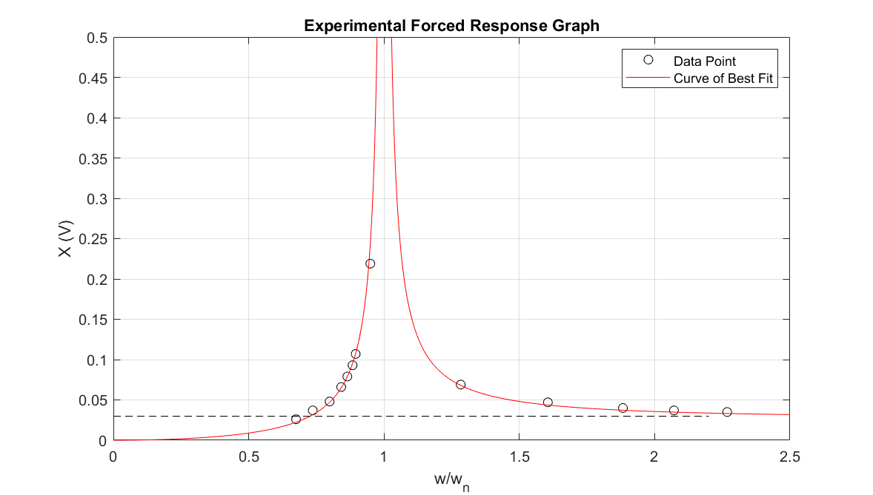

*Figure 2. Experimental Amplitude vs Frequency Ratio of Forced Response System*

## Theoretical Forced Response Graph

The theoretical forced response graph was plotted using given information about the system (refer to Appendix E for code).

Given Information:

* Mass of Rotating Mass: $m=4 g$
* Radius of Rotating Mass: $e=30 mm$
* Combined Mass of Motor, Disc, Unbalanced Mass: $M=248 g$
* Experimental Damping Ratio: $ζ=0.0109$

The experimental damping ratio was obtained from taking the average of the damping ratios for the free response of the system for one cycle.

Graphing Theoretical Forced Response Graph:

The known values of $m, e, M$ and $ζ$ was substituted into equation 4 then the relationship between $X$ and $r$ can be graphed as in *figure 3* (below).

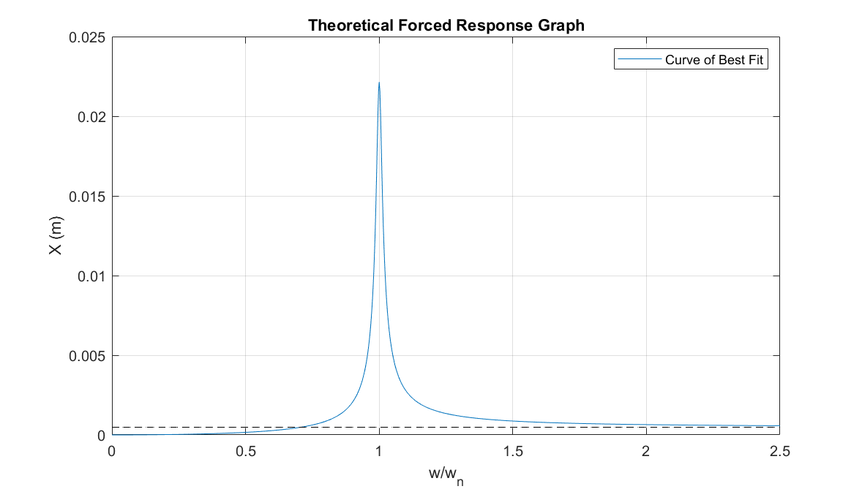

*Figure 3. Experimental Amplitude vs Frequency Ratio of Forced Response System*

# Discussion

## Comparison of Free Response of One Cycle and Five Cycles

Consider the comparison of experimental free responses of one and five cycles of the system (tables 4 and 5). The average $ω_{n}$ for one cycle is $130.3220 rads^{-1}$, and five cycles is $130.3386 rads^{-1}$. The absolute error in $ω_{n}$ is thus:

$$\left|130.3220-130.3386\right|=0.0166$$

The contribution to error may be due to:

* a more noticeable decay in amplitude over more cycles;
* oscilloscope readings being limited to three significant figures (s.f.);
* a change in experimenter between trials 1-3 and trials 4-6 which may have a change in location of strike on the beam and duration of strike;
* and recording of peak values from various locations of the free response wave.

Therefore $ω_{n}$ is considered only accurate to three s.f. due a small absolute error and limitation of the oscilloscope readings to three s.f. The standard deviation in $ω_{n}$ for the free response of one cycle of the system is $0.6483 rads^{-1}$, and five cycles is $0.5086 rads^{-1}$. This small standard deviation suggests the calculated sets of $ω_{n}$ to be precise. The large data set of six trials of $ω_{n}$ also suggests the increased reliability of the data.

## Comparison of Experimental and Theoretical Free Response

The calculated theoretical $ω_{n}$ is $144.3667 rads^{-1}$ and experimental $ω_{n}$ is $130.3220 rads^{-1}$ for one cycle and $130.3386 rads^{-1}$ for five cycles. This grants an absolute error in $ω_{n}$ of:

$\left|144.3667-130.3220\right|=14.0447$ for one cycle

$\left|144.3667-130.3386\right|=14.0281$ for five cycles

The experimental $ω_{n}$ cannot be considered accurate due to the large absolute error. The discrepancy in values may be due to:

* the same contributors of error from the previous section, 5.1;
* an unstable foundation of the beam which may alter the system’s damping coefficient;
* internal resistance of oscilloscope and charge conditioning amplifier;
* an uncalibrated accelerometer;
* and incorrect theoretical information about the system such as its mass and dimensions.

## Comparison of Forced Response Graphs

In *figure 2*, the curve of best fit lied closely to the large set of plotted experimental data; therefore, the curve is reliable and precise to the experimental results. The experimental amplitude was obtained in the units of voltage which cannot be compared quantitatively to the theoretical amplitude in the units of metres. Therefore, the experimental and theoretical amplitude vs frequency ratio graphs can only be compared analytically. The shape of the curve of best fit from *figure 2* is as expected in comparison to the theoretical curve from *figure 3* due to:

* a maximum amplitude at $r=1$;
* a similar slope before the peak;
* a similar slope after the peak;
* amplitude of zero at the zero frequency ratio;
* and existence of the asymptote as the frequency ratio increases.

Therefore, the forced response graphs can be considered qualitatively accurate.

Discrepancies may be due to:

* a lack of experimental data points close to the resonant frequency which can alter the shape of the experimental graph;
* internal resistance of oscilloscope, power supply and charge conditioning amplifier;
* an uncalibrated accelerometer;
* oscilloscope readings limited to two decimal places for frequency;
* and oscilloscope readings limited to zero decimal places for peak-to-peak amplitude;

# Conclusion

The system used for the rotating mass unbalance lab experiment was a rotating disc with uneven mass distribution which applied a sinusoidal excitation force onto the beam. The free and forced response of the beam is detected by the accelerometer and displayed on the oscilloscope where measurements of amplitude, period and frequency were recorded. By vibration analysis of the free response of the system, the experimental undamped natural frequency obtained was $130.3220 rads^{-1}$ for one cycle and $130.3386 rads^{-1}$ for five cycles. The experimental results were precise and reliable but inaccurate to the theoretical value of $144.3667 rads^{-1}$. In the forced response of the system, experimental amplitude vs frequency ratio graph was as expected to the theoretical graph and is therefore accurate and reliable. This report allows readers to gain insight on the concept of free and forced vibration analysis of the rotating mass unbalanced system.

# References

[1] School of Engineering, Brown University. Introduction to Dynamics and Vibrations. [6/7/2019].

<https://www.brown.edu/Departments/Engineering/Courses/En4/Notes/vibrations_forced/vibrations_forced.htm>

# Appendix

Appendix A – MATLAB Code for Lab Calculations: Main File

% rotatingMassUnbalance.m

% LAB 1: ROTATING MASS UNBALANCE

%

% CALLS:

% theoreticalNaturalFrequency.m

% freeResponse.m

% experimentalForcedResponse.m

% theoreticalForcedResponse.m

format compact

% Getting the Theoretical Undamped Natural Frequency

fprintf('\nTHEORETICAL UNDAMPED NATURAL FREQUENCY\n')

[theoretical_omega_n] = theoreticalNaturalFrequency;

% Experimental Observation of Free Response of 1 Cycle

cycles1_x_1 = [136 121 116 97 107 61.1];

cycles1_x_2 = [126 114 109 90.3 99.5 57];

cycles1_T_d = [48 48 48 48.4 48.4 48.5];

fprintf('\nFREE RESPONSE OF 1 CYCLE\n')

[exp1_zeta, exp1_omega_d, exp1_omega_n] = freeResponse(1, cycles1_x_1, ...

cycles1_x_2, cycles1_T_d);

% Experimental Observation of Free Response of 5 Cycles

cycles5_x_1 = [226 271 63.6 62.8 70.3 59.5];

cycles5_x_5 = [177 224 52 51.1 58.6 47.0];

cycles5_T_d = [48 48 48.5 48.25 48.25 48.25];

fprintf('\nFREE RESPONSE OF 5 CYCLES\n')

[exp5_zeta, exp5_omega_n, exp5_omega_d] = freeResponse(5, cycles5_x_1, ...

cycles5_x_5, cycles5_T_d);

% Experimental Observation of Forced Response

f = [14.00 15.28 16.57 17.46 17.93 18.33 18.57 19.69 26.62 33.30 39.05 42.96 47.04];

X = [26 37 48 66 79 93 107 219 69 47 40 37 35];

fprintf('\nEXPERIMENTAL FORCED RESPONSE\n')

experimentalForcedResponse(f, X, exp1_omega_n);

fprintf('\nTHEORETICAL FORCED RESPONSE\n')

theoreticalForcedResponse(exp1_zeta);

Appendix B – MATLAB Code to Calculate Theoretical Undamped Natural Frequency

function [theoretical_omega_n] = theoreticalNaturalFrequency

% GIVEN THEORETICAL INFORMATION

% Dimension of Aluminium beam (m)

b = 40*10^-3;

h = 3*10^-3;

l = 570*10^-3;

% Density of Aluminium (kg/m^3)

rho = 2750;

% Combined Mass of Motor, Disc, Unbalanced Mass (kg)

M = 248*10^-3;

% Mass of Beam (kg)

m_beam = rho*(b*h*l);

% CALCULATING THEORETICAL NATURAL FREQUENCY

% Calculating Theoretical Spring Constant

I = b*h^3/12; % Second Moment of Inertia of Beam Cross-Section

E = 7.1*10^10; % Young's Modulus

k_eq = 192*E*I/l^3; % Spring Constant Formula is given

% Calculating Theoretical Equivalent Mass

m_eq = M + 13/35*m_beam; % Equivalent Mass Formula is given

% Calculating Theoretical Natural Frequency

theoretical_omega_n = sqrt(k_eq/m_eq)

Appendix C – MATLAB Code for Experimental Free Response of System

function [average_zeta, omega_d, average_omega_n] = freeResponse(n, x_i, x_f, T_d)

% CALCULATING EXPERIMENTAL UNDAMPED NATURAL FREQUENCY OF FREE RESPONSE

% Standardising Units

x_i = x_i.*10^-3;

x_f = x_f.*10^-3;

T_d = T_d.*10^-3;

% Calculating Experimental Logarithmic Decrement

delta = 1/n*log(x_i./x_f)

% Calculating Experimental Damping Ratio

zeta = delta./sqrt(4*pi^2 + delta.^2)

average_zeta = mean(zeta);

% Calculating Experimental Damped Natural Frequency

omega_d = 2*pi./(T_d)

% Calculating Experimental Undamped Natural Frequency

omega_n = omega_d./sqrt(1 - zeta.^2)

average_omega_n = mean(omega_n) % Requires Average

Appendix D – MATLAB Code for Experimental Forced Response Graph

function experimentalForcedResponse(f, X, experimental_omega_n)

% Standardising Data

omega = 2*pi*f;

X = X*10^-3;

% Frequency Ratio

r = omega./experimental_omega_n;

% PLOTTING EXPERIMENTAL DATA

fig = figure;

plot(r, X, 'o', 'MarkerEdgeColor', 'black');

axis([0 2.5 0 0.5]);

% GRAPHING CURVE OF BEST FIT

hold on

% Getting the Coefficients to (m*e/M)*r.^2./(sqrt((1 - r.^2).^2 + (2*zeta*r).^2);

r_guess = linspace(0, 2, length(X));

a = lsqcurvefit(@(a, r) a(1)*r.^2./sqrt((1 - r.^2).^2 + (2*a(2)*r).^2), r_guess, r, X);

% a(1) = m*e/M, a(2) = zeta

% Fitting to the Data Set

x = linspace(0, 2.2, length(X));

y = @(r) a(1)*r.^2./sqrt((1 - r.^2).^2 + (2*a(2)*r).^2);

log_fit_type = fittype('a1*r.^2/sqrt((1 - r.^2).^2 + (2*a2*r).^2)', ...

'dependent', {'y'}, 'independent', {'r'}, 'coefficients', {'a1', 'a2'});

best_fit = fit(x', X', log_fit_type, 'StartPoint', [0, 0]);

plot(best_fit, 'r');

hold off

% Plotting Asymptote

hold on

asymptote = @(x) a(2) + 1e-100*x; % BUG: Figure does not show horizontal plot

plot(x, abs(asymptote(x)), 'k--'); % Unexpected plotting behaviour requires abs()

hold off

% Title, Label Axes, Sizing

grid on;

xlabel('w/w_n');

ylabel('X (V)');

legend('Location', 'northeast');

legend('Data Point', 'Curve of Best Fit');

title('Experimental Forced Response Graph');

set(gcf, 'Units', 'Normalized', 'OuterPosition', [0, 0.1, 0.5, 0.5]);

% Resonant Amplitude (m)

experimental_resonant_amplitude = y(1)

Appendix E – MATLAB Code for Theoretical Forced Response Graph

function theoreticalForcedResponse(zeta)

% GIVEN INFORMATION

% Mass of Rotating Mass (kg)

m = 4*10^-3;

% Radius of Rotating Mass (m)

e = 30*10^-3;

% Combined mass of motor, disc, unbalanced mass (kg)

M = 248*10^-3;

% Theoretical Equation of Forced Response of Rotational Unbalance

r = linspace(0, 2.5, 1001);

y = @(r) (m*e/M)*r.^2./sqrt((1 - r.^2).^2 + (2*zeta*r).^2);

% GRAPHING

fig = figure;

plot(r, y(r));

% Plotting Asymptote

hold on

asymptote = @(r) m*e/M + 1e-100*r; % BUG: Figure does not show horizontal plot

plot(r, asymptote(r), 'k--');

hold off

% Title, Label Axes, Sizing

grid on;

xlabel('w/w_n');

ylabel('X (m)');

legend('Location', 'northeast');

legend('Curve of Best Fit');

title('Theoretical Forced Response Graph');

set(gcf, 'Units', 'Normalized', 'OuterPosition', [0, 0.1, 0.5, 0.5]);

% Resonant Amplitude (m)

theoretical_resonant_amplitude = y(1)